(TBC) Title: Predictive Modeling of COVID-19 Variant Peak Prevalence and Duration Using GISAID Data Across 15 Countries

Authors (TBD): Franky Zhang, Rob Paton, Kun Chen, Jaehun Jung*, Chris Overton*, Youngji Jo*

Affiliations:
- Department of Statistics, University of Connecticut, Storr, CT, USA
- Infectious Disease Modelling Team, All Hazards Intelligence, Data, Analytics and Surveillance, UKHSA, London, UK
- Department of Preventive Medicine, School of Medicine, Korea University, Seoul, Korea
- University of Liverpool, Department of Mathematical Sciences, Peach Street, Liverpool, UK
- Departments of Public Health Sciences, School of Medicine, UConn Health, Farmington, CT, USA

Corresponding authors
Youngji Jo: jo@uchc.edu
Chris Overton:
Jaehun Jung

Abstract

Background: Rapid emergence and replacement of SARS-CoV-2 variants underscore the need for early and reliable indicators of variant dominance to guide timely public health response. However, early genomic trajectories are typically short, sparse, and noisy, with strong fluctuations and substantial cross-country heterogeneity in sequencing intensity and reporting.

Methods: We develop a scalable forecasting framework that predicts whether new variants will reach high prevalence and how long they will persist based on their initial genomic growth patterns. Using more than nine million sequences from 15 countries (GISAID, 2020–2024), we characterize dominance through peak prevalence and duration above 10% and extract early growth descriptors from the first 2–4 weeks after a lineage surpasses 1% frequency. Outcomes were classified using multiple models (GLM, GAM, SVM, CART, Elastic Net, and SuperLearner). We evaluated performance based on accuracy and utilized SHAP analysis to interpret feature importance.

Results: The Super Learner ensemble model achieved the best performance, achieving up to 0.85 accuracy for peak-share prediction, and up to 0.77 accuracy for duration classification—substantially outperforming all individual models. SHAP analysis showed that variants achieving high peaks exhibit strong but structurally coherent early growth, whereas prolonged dominance is associated not with early surges but with sustained, moderate short-term fluctuations embedded within a stable trajectory.

Conclusion: This framework defines minimum surveillance thresholds (≥100 sequences in 30 days, ≥1% detection share), variant grouping rules, and noise-filtering protocols, enabling cross-country comparison and country-specific forecasting. It provides a lightweight, reproducible early-warning tool for genomic surveillance and real-time epidemic intelligence.

Significance: Our study demonstrates that the earliest genomic growth trajectories encode robust and interpretable signals of a lineage’s eventual epidemiological impact. By integrating handcrafted early-growth indicators with standardized time-series descriptors derived from an established statistical framework, we develop a scalable, sequence-only modeling approach that accurately predicts both the peak prevalence of emerging SARS-CoV-2 variants and the duration for which they sustain epidemiological dominance (defined as maintaining a prevalence above 10 percent). Using only 2–4 weeks of early genomic observations—well before variants approach their national peaks—this framework provides a lightweight, reproducible, and globally applicable early-warning system to support real-time genomic surveillance and proactive public health decision-making.

Introduction

The SARS-CoV-2 pandemic has provided a unique opportunity to observe viral evolution and competition in real time, offering insights into broader respiratory pathogen dynamics (Harvey et al., 2021). As variants have demonstrated clear patterns of emergence, dominance, and replacement, this viral succession has created a natural experiment in pathogen evolution. Identifying early indicators of dominance carries profound implications for public health planning, including vaccination strategies and resource allocation. Consequently, global health organizations like the Centers for Disease Control and Prevention (CDC) and the World Health Organization (WHO) have emphasized that SARS-CoV-2 variant surveillance remains critical for pandemic preparedness ^{1,2}.

Despite the global experience of multiple SARS-CoV-2 infection waves, timely identification of variants capable of driving new surges remains difficult due to several intertwined factors. Capturing early signals of variant dominance is particularly challenging because early trajectories are short, sparse, and noisy, with strong daily fluctuations and large cross-country variation in sequencing practices. Defining the initial observation period is also delicate including too many early zeros or stochastic spikes can distort growth signals and obscure true trends. Moreover, the virus’s high mutation rate continually generates a diverse pool of variants with distinct genetic profiles that affect transmissibility, immune escape, and pathogenicity, complicating efforts to identify which low-prevalence lineages (e.g., 0.01–3%) are likely to dominate. The challenge is compounded by variability in sequencing capacity across countries, with low-resource settings often facing delays in generating sufficient genomic data to detect emerging variants early. For instance, while high-sequencing settings (~1,000 sequences/week) enable robust monitoring, regions with limited infrastructure (~100 sequences/week) often face detection delays and incomplete genomic coverage. Recent analyses show that 78% of high-income countries sequenced over 0.5% of their COVID-19 cases, compared with only 42% of low- and middle-income countries ³.

Recent advances in machine learning–based forecasting have addressed parts of this problem but still leave critical gaps. Hamelin et al. (2025) ⁴ showed that deep learning and protein language models can predict viral evolution and immune escape before variants emerge, facilitating anticipatory vaccine design but requiring rich molecular and structural datasets (specify more). In contrast, Chowell and Skums (2024) ⁵ integrated machine learning with mechanistic ODE frameworks to improve epidemic forecast accuracy and interpretability, yet their models rely on extensive epidemiological inputs and multiple data streams (again specify)—constraints that limit real-time applicability in low-coverage surveillance settings. This motivates our effort on molecular fitness inference and real-time global forecasting by developing a data-efficient, early-growth-based framework that achieves high predictive accuracy with a minimum number of sequences.

Based on comprehensive genomic data from the Global Initiative on Sharing All Influenza Data (GISAID), we analyze lineage dynamics across 15 high-burden countries from January 2020 to May 2024, addressing two fundamental questions: which variants emerge to dominance and how long they sustain it. Leveraging this large dataset, we established minimum surveillance thresholds, variant grouping criteria, noise-filtering protocols, and cross-country comparability, delivering a lightweight and scalable early-warning tool for variant dominance prediction, defined as: monthly peak share and duration of circulation above 10% share. These findings not only advance methodological approaches for genomic surveillance but also provide a reference framework for anticipating the emergence and persistence of future SARS-CoV-2 variants.

Methods

Data source. Genomic data for this study were obtained from GISAID (https://www.gisaid.org/) ⁶. Established in 2017 as the Global Initiative on Sharing All Influenza Data and later expanded with its EpiCoV repository to include SARS-CoV-2 sequences, GISAID now provides access to millions of viral genomes complete with collection dates, geographic origins and sequencing-platform metadata—enabling researchers worldwide to track the virus's evolution, transmission, and mutations. Since its launch in January 2020, GISAID has been regularly updated with submissions from various countries, showcasing collaborative efforts in combating the pandemic. Within this shared framework, viral evolution is tracked through the Pango lineage system, in which lineages are defined when clusters of sequences exhibit consistent genetic divergence and epidemiological relevance. Early variants were labeled with letters for major clades (A, B) and numbered sequentially for descendant lineages, providing a standardized and scalable naming structure. Following the WHO/CDC-endorsed Pango lineage nomenclature (20), it represents together 9.0 million of the 9.5 million sequences across XX countries, as of XXX. We analyzed the 15 countries that had reported the largest number of cumulative SARS-CoV-2 sequences to ensure comprehensive genomic coverage, including over 3,000 SARS-CoV-2 lineages from January 2020 to May 2024. Among these, the United States leads with 2.9 million sequences, while Luxembourg contributes the fewest (25,000). we identified 1151 distinct variants across these countries, with a median of 72 variants per country (Q1 = 57, Q3 = 121; see Table S1). We selected the United States, the United Kingdom, and South Korea as case examples for our analyses as shown in Table 1, since all three maintained established genomic surveillance programs yet represent diverse epidemiological and health system contexts.

Country | Year | Number of Cases | Top Five Pango Lineages (Annual Proportional Share)
United States | 2020 | 18,903,169 | B.1 (1.1%); B.1.1 (1.1%); B.1.595 (1.1%); B.1.369 (1.1%); B.1.243 (1%)
 | 2021 | 196,861,939 | B.1 (1.0%); B.1.617.2 (1%); AY.44 (0.9%); B (0.9%); AY.25 (0.9%)
 | 2022 | 227,680,907 | BA.2 (0.7%); BA.1.1 (0.6%); BA.2.12.1 (0.6%); BA.2.3 (0.6%); BA.2.9 (0.5%)
 | 2023 | 71,328,981 | XBB.1.5 (0.5%); XBB.1.5.10 (0.4%); XBB.1 (0.4%); XBB.1.5.15 (0.4%); XBB.1.5.49 (0.4%)
 | 2024 | 9,457,427 | JN.1 (1.1%); JN.1.8 (1.1%); JN.1.18 (1%); JN.1.7 (1%); JN.1.4 (1.0%)
United Kingdom | 2020 | 13,728,198 | B.1.1 (1.2%); B.1 (1.2%); B.1.1.37 (1%); B.1.1.1 (1%); B.1.177 (0.9%)
 | 2021 | 84,393,505 | AY.4 (1.5%); B.1.617.2 (1.5%); AY.122 (1.5%); AY.5 (1.5%); AY.111 (1.5%)
 | 2022 | 79,974,012 | BA.2 (1.3%); BA.2.3 (1.2%); BA.1.1 (1.2%); BA.2.10 (1.2%); BA.1 (1.2%)
 | 2023 | 8,416,483 | XBB.1.5 (0.9%); XBB.1.9.1 (0.7%); CH.1.1.1 (0.7%); XBB.1.5.7 (0.7%); XBB.1.5.18 (0.7%)
 | 2024 | 934,727 | JN.1 (2%); JN.1.7 (1.9%); KP.2 (1.7%); KP.3 (1.6%); JN.1.8 (1.5%)
South Korea | 2020 | 5,878 | B.1.497 (37.3%); B.1 (9.8%); B.1.1 (8.0%); B.41 (2.9%); A (2.8%)
 | 2021 | 215,082 | AY.69 (11.6%); B.1.617.2 (11.6%); AY.122 (9.4%); AY.122.5 (8.0%); B.1.619.1 (6.4%)
 | 2022 | 2,827,981 | BA.5.2 (2.0%); BA.5.2.1 (2.0%); BA.5.1 (1.8%); BA.2.3 (1.8%); BA.2 (1.7%)
 | 2023 | 4,438,592 | XBB.1.5 (1.2%); XBB.1.16 (1.0%); EG.1.6 (1.0%); EG.1 (1.0%); XBB.1.9.1 (1.0%)
 | 2024 | 225,726 | JN.1.4 (4.2%); JN.1 (4.1%); JN.1.20 (3.9%); JN.1.4.5 (3.8%); JN.1.5 (3.4%)
Table 1. Descriptive summary of GASID data showing the distribution of raw PANGO lineages in the United States, the United Kingdom, and South Korea.

Data processing. To ensure the reliability of these national-level share estimates, we identified valid analytical periods for each country, using sequencing coverage standards recommended by the World Health Organization ⁷. A valid period was defined as a continuous stretch of at least three calendar weeks, each containing at least 100 sequences and four days with non-zero sampling. As sparse sampling introduces significant noise and bias, as noted in previous studies ⁸ and WHO surveillance guidance⁹¹⁰, we retained only those variant–country combinations whose entire observed share trajectories fell within the criteria, which ensures that early growth patterns and peak prevalence estimates are derived from consistent, representative data. This resulted in 24,286 out of 26,152 lineages, excluding 1,866 variants (approximately 7%). The overall data processing workflow includes data cleaning, variant grouping, and model data generation, as summarized in Figure 1.

Variants grouping. We segmented the global epidemic into six lineage-specific periods – specify the periods timelines and names-- corresponding to the major VOC replacement timelines.[ref] Within each period, SARS-CoV-2 lineages were grouped into variants based on aggregated case proportions, retaining only those that exceeded a 1% share at any point (is this 1% based on global or country-specific??). Across the six periods, this procedure yielded 1040 grouped variants, while all remaining lineages were pooled into the “others” category. This classification consolidates highly granular lineage data into a tractable number of epidemiologically meaningful groups. The grouping procedure was applied independently for each country to account for geographic heterogeneity in variant circulation. Figure 2 illustrates the evolving landscape of grouped SARS-CoV-2 variants in the United States, the United Kingdom, and South Korea.

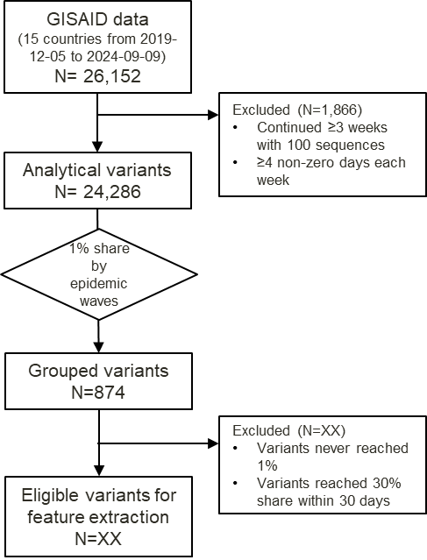

Figure 1. Overview of the data processing workflow, including data inclusion, exclusion, and grouping steps.

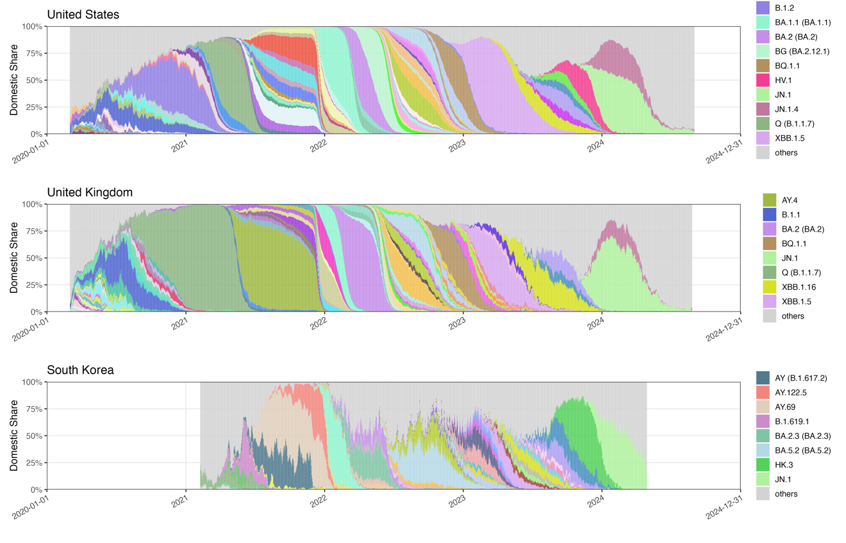
Figure 2. Time-series distribution of grouped SARS-CoV-2 PANGO lineages during the analytical period in the United Kingdom, the United States, and South Korea. Only lineages with monthly maximum share > 30% and > 10% share sustained for > 100 days are shown in the legend.

Early Pandemic Era (2020–2021): High signal-to-noise, transmissibility-driven dynamics
In the pre-Omicron era, population immunity was low and variant fitness was largely governed by transmissibility advantages. This produced:
- Large, smooth selective sweeps (e.g., Alpha, Delta)
- High inter-country concordance in peak timing and magnitude
- Clear exponential growth patterns with strong early slopes
- Low entropy and minimal structural irregularity in early trajectories
Under these conditions, simple linear-slope features and magnitude-based descriptors (e.g., peak_val, early-increase runs) were highly predictive. The model’s strong performance in this period reflects the high signal-to-noise ratio: early growth trajectories closely mirrored intrinsic fitness.

Late Pandemic Era (2022–2024): Immune-escape–mediated, multi-lineage competition
In contrast, the Omicron period is characterized by:
- High background immunity, heterogeneous across countries
- Multiple co-circulating lineages competing within narrow fitness margins
- Slower, noisier, more stochastic growth curves
- Shared genetic origins (e.g., BA.2 → BA.5 → BQ → XBB → JN.1) producing partial cross-immunity
- Frequent transient rises that do not progress to dominance
This “crowded fitness landscape” produces cryptic early signals, where:
- Early slopes are weaker predictors of ultimate success
- Structural features—entropy, motif complexity, autocorrelation timescales—become more important
- Countries diverge sharply in observed peaks depending on their immune-history profile
- Duration becomes easier to predict than peak magnitude
This complexity explains why models reliably predict duration (>100 days) even when peak magnitude is misclassified, particularly in countries with sparse sequencing or highly variable immune landscapes.

Implications for Model Performance and Interpretation
These shifting dynamics help explain key empirical patterns observed in our study:
- Stronger model performance in the early pandemic
  - High-growth signals are easier to detect.
  - Early slopes are reliable predictors.
  - Less cross-country heterogeneity.
- Lower stability of peak-prediction in the Omicron era
  - Variants differ more in immune-escape profiles than intrinsic transmissibility.
  - Countries diverge depending on prior infection waves and booster timing.
  - Early trajectories encode weaker or more irregular signals.
- Higher accuracy for predicting duration than peak in late pandemic periods
  - Persistence is governed by small-scale but recurrent fluctuations rather than early exponential growth.
  - SHAP confirms that moderate, sustained variability (not early surges) predicts long-term circulation.
- Importance of structural descriptors increases over time
  - Late-era variants require attention to entropy, autocorrelation, and symbolic dynamics.
  - These features capture information that simple growth-rate metrics miss.

Summary
The interaction of threshold choice and pandemic phase reveals that:
- A 30% peak threshold is scientifically justified because it captures both sweeping and persistent variants of epidemiological significance.
- Early-growth predictive signals are strong and coherent in the early pandemic but become weaker and structurally more complex in the Omicron era.

Outcome measures. We examine whether early growth patterns of SARS-CoV-2 variants—captured by their initial national-level share trajectories— forecast two outcomes: the weekly maximum domestic share (peak) and the number of days (duration) a variant maintains a domestic share above 10%¹². These two distinctive measures can better represent a variant’s competitive strength and epidemiological relevance than AUC alone, which can be inflated by long periods of low-level circulation. Daily sequence counts were aggregated using a rolling seven-day window, within which the variant’s proportion was computed as its sequence count divided by the total sequences collected over the same window. This windowed formulation reduces sensitivity to day-level reporting noise while capturing the variant’s strongest observed competitive position. ¹¹. This continuous measure, ranging from 0 to 1, characterizes the intensity of a variant’s competitive advantage. Its empirical distribution is highly right-skewed, with most variants attaining only modest peaks (median ≈ 0.08; IQR: 0.03–0.20). To mitigate the influence of extreme values and enhance model stability, we discretized peak share into an ordered three-level outcome: <10%, 10–20%, and >20%. (add a sentence of the chosen threshold points—based on IQR??) Given that values exceeding 20% fall within the extreme upper tail of the distribution, this uppermost category is interpreted as representing high-peak, or dominant, variants. Similarly, the empirical distribution of duration is highly skewed, with nearly one-third of the variants never exceeding the 10% threshold for more than 30 days. To address this heterogeneity and improve stability, the duration was grouped into three ordinal categories: 0–30, 31–100, and 100+ days. ¹³.

Predictive features. The start point of the initial period was defined when the variants first reached a 1% share in their respective country. (add justification) From this point, we considered a different set of observation periods from 14 to 28 days. From these early share sequences, we then constructed two complementary sets of predictors. The first group comprised handcrafted, epidemiologically motivated predictors designed to capture basic growth dynamics. These included the overall log-linear slope (overall growth or decline rate), short-window slopes over seven days, the longest increasing run (consecutive growth days), and the non-zero count (number of days with non-zero share). All features were computed from the early stage share trajectories using base R functions and custom routines. The second set was drawn from the catch22 library ¹⁵, accessed via the Rcatch22 package, which provides 22 minimally redundant descriptors of time-series structure such as entropy, fluctuation scaling, and motif frequency. The catch22 features are computationally efficient, robust to short and noisy sequences, and broadly applicable without parameter tuning—an important advantage given the heterogeneity of early trajectories. By combining interpretable, domain-informed measures with standardized machine-learning–oriented descriptors, this approach balances epidemiological interpretability with statistical power and enhances generalizability across diverse variant profiles. Together, these features quantify each trajectory’s level, variability, early acceleration, and persistence, providing a rich basis for downstream prediction of peak share and time to dominance. We based our summary‐feature approach on established methods for extracting interpretable time‐series characteristics ¹⁶ and on prior applications to SARS‐CoV-2 variant growth ¹¹, yielding a compact set of metrics that capture level, variability, early acceleration, and persistence.

Prediction Model. we employed a diverse set of machine learning regressors suited for heterogeneous temporal data. These included generalized linear models ¹⁷, generalized additive models ¹⁸, regularized methods such as Elastic Net ¹⁹, kernel-based models ²⁰, neural networks ²¹, and tree-based approaches ²². We further applied the SuperLearner R package ²³, an ensemble learning framework that optimally combines multiple algorithms via cross-validated stacking. We applied a SuperLearner ensemble combining CART, GLM, and Elastic Net base learners to balance interpretability, flexibility, and regularization. This ensemble pools complementary models—CART for nonlinear patterns, GLM for main effects, and Elastic Net for correlated predictors—through cross-validated stacking to approximate the optimal weighted combination. By jointly leveraging information across countries or feature sets, the approach stabilizes variant fitness estimates and mitigates noise in data-sparse contexts. [add a couple of sentences on Figure 2. How to divide the train and test data and what is CV folds and algorithms for fit model, evaluate test fold, model score etc.]

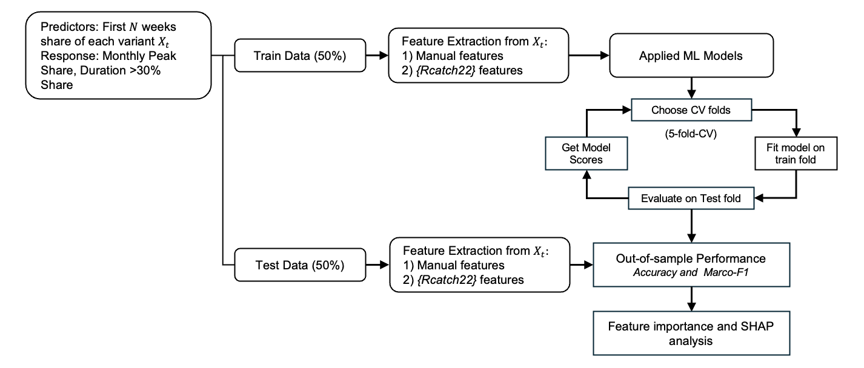
Figure 2. Modeling framework. Variant shares from the first N weeks were used to predict monthly peak share and duration above 10% share. Features included handcrafted and Rcatch22 descriptors.

Evaluation of model performance and interpretation. Performance was assessed separately for the two outcomes to align the evaluation with their statistical nature. For the categorical outcome of weekly peak and dominance duration, we reported overall accuracy and macro-F1, where accuracy summarizes the proportion of correct classifications and macro-F1 balances performance across imbalanced classes by averaging precision and recall equally ²⁵. To further interpret model behavior, we applied variable importance analysis and SHAP decomposition ²⁶, which together identify key predictors and quantify their contributions at both global and local levels. The entire workflow, from feature extraction to model fitting, evaluation, and interpretation, is summarized in Figure 2.

Results

Comparison of model prediction and observed dominant variants. Table 3 summarizes model performance for the three most well-sampled countries under the operational definition of dominance (peak >20% and duration ≥100 days). In both the United States and the United Kingdom, the model showed strong consistency: nearly all major lineages—including BA.2, BA.5 sublineages, BQ.1.1, XBB.1.5, and JN.1—were correctly classified for both peak and duration, with only early variants (e.g., B.1.2 in the U.S., B.1.1 and B.1.1.7 in the U.K.) showing underestimation of peak magnitude. Results in South Korea were more heterogeneous: dominant variants were generally detected, but peak share was frequently underpredicted for Delta-related AY lineages and for later Omicron sublineages such as JN.1. Despite this, duration classification remained highly accurate across all three countries. Overall, the model achieves high agreement in the U.S. and U.K., with reduced peak-prediction stability in South Korea due to more variable early growth dynamics.

Country | Lineage | Onset date | Offset date | Pred. Peak | Obs. Peak | Peak. Diff | Pred. Dur. | Obs. Dur. | Dur. Acc.
United States | B.1.2 | 2020-03-09 | 2023-07-17 | 0.10–0.20 | >0.20 | F | 31–100 | 100+ | F
 | Q (B.1.1.7) | 2020-03-12 | 2024-03-04 | 0.10–0.20 | >0.20 | F | 31–100 | 100+ | F
 | BA.2 (BA.2) | 2020-04-03 | 2024-08-22 | >0.20 | >0.20 | T | 100+ | 100+ | T
 | XBB.1.5 | 2020-04-04 | 2024-07-16 | >0.20 | >0.20 | T | 100+ | 100+ | T
 | AY.103 | 2020-05-14 | 2023-02-01 | >0.20 | >0.20 | T | 100+ | 100+ | T
 | BG (BA.2.12.1) | 2020-08-18 | 2024-08-28 | >0.20 | >0.20 | T | 100+ | 100+ | T
 | BF (BA.5.2.1) | 2021-11-05 | 2024-04-11 | >0.20 | >0.20 | T | 100+ | 100+ | T
 | BQ.1.1 | 2021-11-30 | 2024-03-27 | >0.20 | >0.20 | T | 100+ | 100+ | T
 | HV.1 | 2023-01-09 | 2024-08-16 | >0.20 | >0.20 | T | 100+ | 100+ | T
 | JN.1 | 2023-01-09 | 2024-08-31 | >0.20 | >0.20 | T | 100+ | 100+ | T
 | JN.1.4 | 2023-09-13 | 2024-08-29 | >0.20 | >0.20 | T | 100+ | 100+ | T
 | others (n = 68) | 2020-03-02 | 2024-08-16 | - | - | - | - | - | -
United Kingdom | B.1.1 | 2020-03-02 | 2022-06-23 | 0.10–0.20 | >0.20 | F | 31–100 | 100+ | F
 | Q (B.1.1.7) | 2020-03-03 | 2022-03-03 | 0.10–0.20 | >0.20 | F | 100+ | 100+ | T
 | BA.2 (BA.2) | 2021-01-01 | 2024-01-13 | >0.20 | >0.20 | T | 100+ | 100+ | T
 | BA.5.1 (BA.5.1) | 2022-01-12 | 2024-05-10 | >0.20 | >0.20 | T | 100+ | 100+ | T
 | BA.5.2 (BA.5.2) | 2022-01-17 | 2024-02-12 | >0.20 | >0.20 | T | 100+ | 100+ | T
 | BQ.1.1 | 2022-02-11 | 2024-01-01 | >0.20 | >0.20 | T | 100+ | 100+ | T
 | XBB.1.5 | 2022-10-30 | 2024-05-28 | 0.10–0.20 | >0.20 | F | 100+ | 100+ | T
 | XBB.1.16 | 2023-01-01 | 2024-04-17 | >0.20 | >0.20 | T | 100+ | 100+ | T
 | JN.1.4 | 2023-09-18 | 2024-08-25 | >0.20 | >0.20 | T | 100+ | 100+ | T
 | JN.1 | 2023-09-21 | 2024-08-24 | >0.20 | >0.20 | T | 100+ | 100+ | T
 | others (n = 76) | 2020-03-02 | 2024-07-10 | - | - | - | - | - | -
South Korea | B.1.619.1 | 2021-02-22 | 2021-09-21 | >0.20 | >0.20 | T | 100+ | 100+ | T
 | AY (B.1.617.2) | 2021-04-22 | 2023-07-11 | 0.10–0.20 | >0.20 | F | 100+ | 100+ | T
 | AY.69 | 2021-05-15 | 2022-02-10 | 0.10–0.20 | >0.20 | F | 100+ | 100+ | T
 | AY.122.5 | 2021-08-08 | 2022-03-04 | 0.10–0.20 | >0.20 | F | 100+ | 100+ | T
 | BA.2.3 (BA.2.3) | 2021-12-29 | 2023-03-15 | >0.20 | >0.20 | T | 100+ | 100+ | T
 | BF (BA.5.2.1) | 2022-05-10 | 2023-04-15 | 0.10–0.20 | >0.20 | F | 31–100 | 100+ | F
 | BA.5.2 (BA.5.2) | 2022-05-11 | 2024-01-22 | >0.20 | >0.20 | T | 100+ | 100+ | T
 | XBB.1.5 | 2022-11-23 | 2023-12-11 | 0.10–0.20 | >0.20 | F | 100+ | 100+ | T
 | EG.5.1.1 | 2023-05-16 | 2024-03-27 | 0.10–0.20 | >0.20 | F | 100+ | 100+ | T
 | HK.3 | 2023-07-04 | 2024-04-15 | >0.20 | >0.20 | T | 100+ | 100+ | T
 | JN.1 | 2023-10-24 | 2024-04-28 | 0.10–0.20 | >0.20 | F | 31–100 | 100+ | F
 | others (n = 37) | 2021-02-08 | 2024-02-20 | - | - | - | - | - | -
Table 3. Comparison of observed and predicted variant dominance in selected countries, defined as duration ≥100 days and peak >20%.

Country specific model performance. Figure 3(a) and 3(b) compare model accuracy for predicting variant dominance across 15 countries using 28-day and 21-day inputs, respectively. Across both input lengths, the SuperLearner ensemble consistently attains the highest accuracy, with notable gains in countries such as Denmark, France, the United Kingdom, and the United States. In contrast, individual models such as GLM, SVM, and CART show substantially lower accuracy, particularly in countries with noisier or sparser sequencing data. Overall, these results highlight the robustness of ensemble learning for forecasting monthly peak share, with performance advantages that persist across different input windows and national contexts.

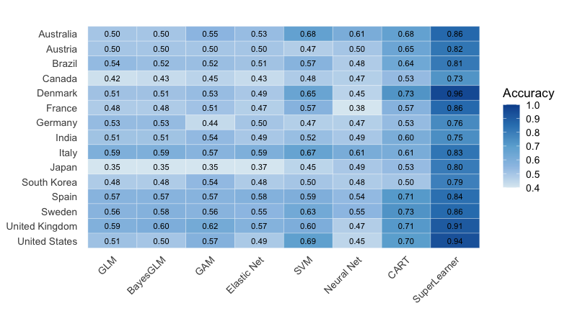
Figure 3(a). Heatmap of accuracy across models and countries for predicting monthly maximum share using a 21-day input. Blue = higher, white = lower.

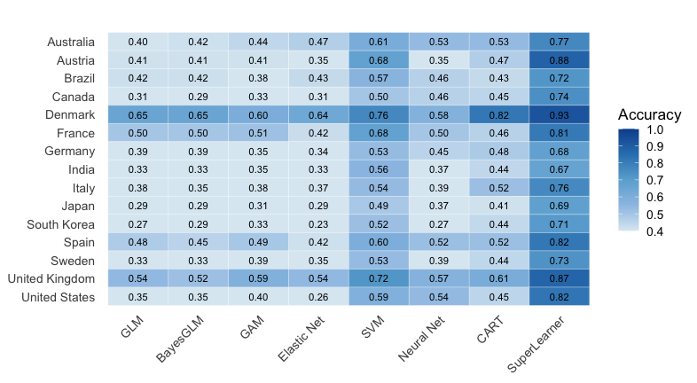
Figure 3(b). Heatmap of accuracy across models and countries for predicting maximum share using a 21-day input. Blue = higher, white = lower.

SHAP analysis. The SHAP analysis for the peak-share outcome (>20 percent) shows that both the magnitude and structural coherence of early growth are key determinants of whether a lineage reaches a high weekly peak (Figure 4a). The early maximum value (peak_val) exerts the strongest positive influence, indicating that lineages with substantial early expansion are most likely to achieve high peak prevalence. Later positive deviations (outlier_timing_pos) further reinforce this signal, while early isolated spikes tend to reduce predicted peaks, reflecting their interpretation as noise rather than evidence of sustained transmission. Structural characteristics of the trajectory refine these effects: higher entropy_pairs consistently lowers predictions, indicating that irregular symbolic patterns are not conducive to strong expansion, whereas longer autocorrelation timescales (acf_timescale) and moderate short-term fluctuation (high_fluctuation) reflect more persistent and coherent growth. Measures of geometric and nonlinear structure, including embedding_dist and ami2, similarly distinguish lineages whose early trajectories are organized and dynamically consistent. Overall, variants that combine strong early amplification with stable and structurally coherent growth are more likely to achieve high peak share.

The SHAP analysis for dominance duration (>100 days) reveals a distinct pattern from the peak-share outcome (Figure 4b). Early sharp peaks, reflected in peak_val, reduce predicted duration, indicating that rapid initial surges are characteristic of short-lived waves rather than sustained circulation. In contrast, greater short-horizon forecast variability (forecast_error) and stronger incremental day-to-day fluctuations (high_fluctuation) contribute positively, suggesting that lineages exhibiting recurrent, moderate short-term variation—rather than a single early spike—are more likely to persist. Higher embedding_dist and elevated transition_variance reduce predicted duration, implying that geometric irregularity and unstable state-switching signal transient rather than resilient growth. Overall, prolonged dominance appears to arise not from explosive early expansion but from continued small-scale dynamism embedded within a coherent and structurally stable growth trajectory.

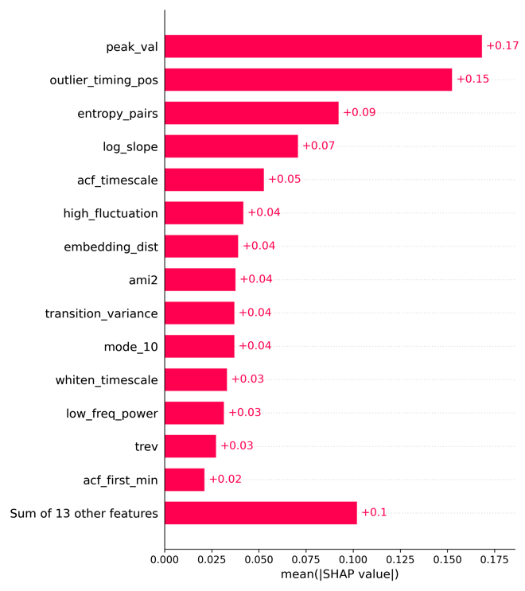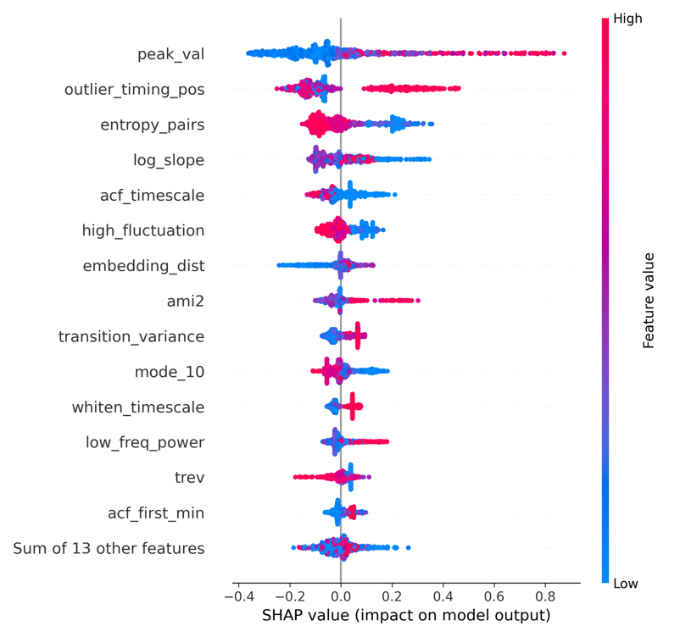

Figure 4 (a). SHAP values from the SuperLearner (21-day input) for predicting variant monthly peak share across 15 countries.

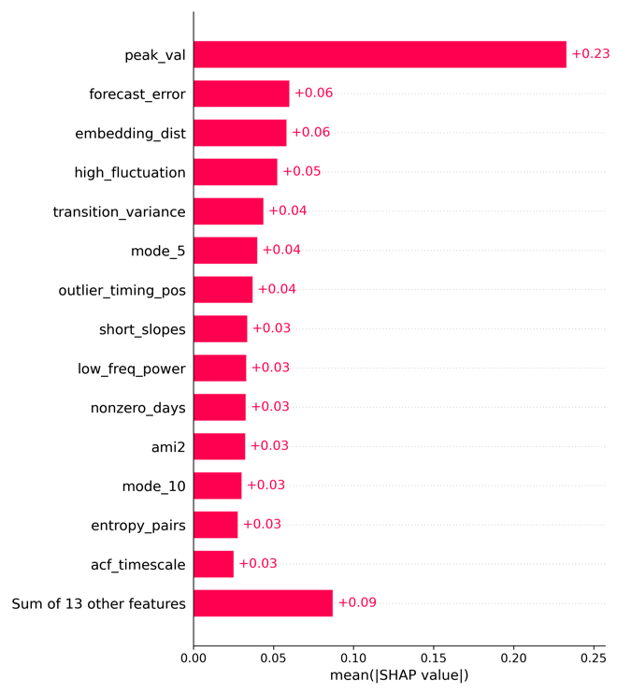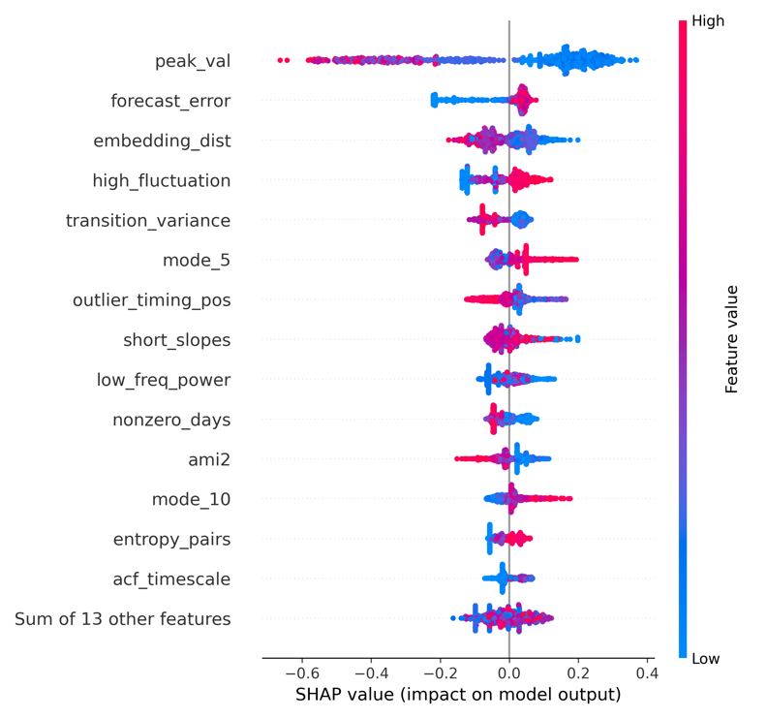
Figure 4 (b). SHAP values from the SuperLearner (21-day input) for predicting days above 10% share across 15 countries.

Discussion

In this study, we demonstrate that the earliest genomic growth trajectories—captured within just two to four weeks of a variant’s emergence—encode robust and interpretable signals capable of forecasting its eventual epidemiological dominance. By integrating domain-specific growth indicators with standardized time-series descriptors, our SuperLearner ensemble framework achieved high predictive accuracy for both peak prevalence and duration across diverse national contexts, consistently outperforming individual algorithms. Crucially, our interpretability analysis reveals that these two dimensions of dominance are driven by distinct dynamical signatures: while high peak prevalence is primarily determined by the magnitude and structural coherence of early expansion, prolonged duration is associated not with explosive initial surges, but with sustained, moderate fluctuations embedded within a stable growth trajectory. These findings validate a scalable, sequence-only approach to real-time surveillance, providing public health systems with a lightweight early-warning tool that operates well before variants approach their national peaks.

The mechanisms underlying variant dominance—and thus the sources of forecasting uncertainty—shifted markedly over the course of the pandemic. The early pandemic phase (2020–2021) was characterized by large, sweeping waves of closely related lineages (e.g., Delta vs. Delta Plus), where dominance was governed primarily by raw transmissibility. In this landscape, signals were distinct and waves were synchronized. In contrast, the later pandemic (2022–2024) involves far more 'cryptic signals' arising from a pool of very diverse, competing lineages (e.g., XBB, JN.1). Rather than a single variant sweeping the population, we observe complex co-circulation where multiple variants continually compete for niche dominance. In this context, our model’s ability to detect 'persistent' but not necessarily 'knockout' variants becomes crucial. By identifying lineages likely to sustain a 20–40% share, the framework highlights the variants that are 'hanging around' long enough to diversify, effectively flagging the breeding grounds for future child lineages.

In our framework, predictive uncertainty primarily stems from two intertwined sources: early growth and detection delay ²⁷—which together shape the heterogeneity observed across countries ²⁸. Variants exhibiting extremely rapid initial expansion compress both biological signal and stochastic noise into short time windows, making growth-related features (e.g., short-window slopes, fluctuation metrics) highly sensitive to sampling variability. In high-coverage settings such as Denmark or the United Kingdom, dense sequencing smooths these fluctuations and yields stable slope estimates; in contrast, sporadic sampling in countries like Brazil or South Korea amplifies volatility, occasionally misclassifying transient spikes as sustainable growth. Detection delays further compound these disparities by shifting each country’s analytical “Day 0” away from the true biological onset. In low-throughput systems, a variant may already be mid-growth when it first exceeds the 1 % threshold, leading to truncated or distorted early trajectories and underestimation of eventual dominance. This asymmetry explains why the model achieved near-perfect accuracy in data-rich settings but tended to underpredict peaks and durations in countries with limited sequencing continuity. Naïve growth-rate models struggle under these conditions, as a single spurious point or reporting lag can heavily bias slope estimates. Machine learning approaches are better suited because they integrate multiple features beyond simple growth rates, capture variability and persistence, and learn from diverse historical examples, making them more robust to noise and heterogeneity.

The mechanisms underlying variant dominance—and thus the sources of forecasting uncertainty and cross-country heterogeneity—shifted markedly over the course of the pandemic ²⁹. During the early pandemic (2020–2021), when immunity was minimal, dominance was governed by viral transmissibility, resulting in globally synchronized peaks with relatively small variability—e.g., Alpha and Delta reached 80–95% prevalence in most countries (UK 98%, Germany 93%, Japan 93%, Spain 92%) with peak errors typically <20%. In contrast, the later period (2022–2024), dominated by Omicron sublineages, showed much greater heterogeneity: for BA.2, observed peaks ranged from 46% in Japan to 82% in Brazil (Δ ≈ 35%), and for JN.1, from 33% in Brazil to 79% in the UK (Δ > 45%). Correspondingly, peak prediction errors expanded to 30–40% in countries like France, Australia, and Brazil. These disparities emerged as immune escape became the principal determinant of variant success, with national immune landscapes—shaped by vaccination timing and prior infection history—causing divergent outcomes even among well-connected regions. Figgins and Bedford (2025)²⁹ demonstrated that SARS-CoV-2 variant success transitioned from transmissibility-driven to immune-escape-driven dynamics as global immunity accumulated. Using genomic frequency data, they quantified time-varying fitness and selective pressure, showing that shifts in population immunity, rather than fixed viral traits, explain changing epidemic growth patterns across countries. Their latent immunity model accurately recapitulated human serological relationships, revealing that immune structure strongly predicts geographic differences in variant fitness.

Recent work by Abousamra et al. ³⁰ provides similar empirical support for the predictive value of fitness-based and frequency-growth models, demonstrating that relatively simple statistical models—such as multinomial logistic regression (MLR), fixed-growth advantage (FGA), and growth-advantage random walk (GARW)—can achieve median absolute errors below 2 % and mean errors of 6–12 % in 30-day forecasts under robust sequencing coverage, underscoring that the key limitation is data quality and timeliness, not model complexity. Their results confirm that variant-frequency trajectories contain sufficient early-stage information to anticipate near-term dominance, aligning closely with our finding that early growth signatures within the first 2–4 weeks are highly informative for forecasting both peak prevalence and persistence. Importantly, Abousamra et al. highlight that forecast accuracy deteriorates sharply in settings with sparse or delayed genomic surveillance, where submission lag and low weekly sequencing (< 50–100 samples) inflate forecast error to >10 %, suggesting roughly 1,000 sequences per week suffice for robust short-term forecasting. Together, these findings reinforce that predictive accuracy is bounded less by algorithmic sophistication than by timely, high-volume genomic data and adaptive calibration.

In this respect, a major contribution of our study is its comprehensive cross-country comparison of how dominant variants evolved across distinct pandemic phases, revealing how the drivers of dominance and uncertainty shifted over time. Given these dynamics, our study provides practical guidance on the minimum sequencing requirements and surveillance protocols (e.g. maintaining ≥100 sequences in the previous 30 days with ≥1% share detection threshold) needed to reduce early noise and improve the reliability of variant forecasting. The analysis demonstrates a scalable, data-driven framework for early-stage prediction of SARS-CoV-2 variant dominance using sequence-derived time-series features alone can achieve high forecasting performance by incorporaintg early-stage sequence-derived temporal features—particularly growth slopes, temporal entropy, and fluctuation dynamics—including linear, kernel-based, and ensemble methods across diverse epidemiological contexts. Using multi-country data, we also established a systematic approach for defining the initial observation phase, which minimizes early-stage noise, enhances detection of early growth signals, and ensures comparability of forecasting results across diverse surveillance settings.

This study has several methodological and data-related limitations that warrant consideration. First, although the analytical window was anchored to the first observation of a 1% variant share to mitigate stochastic noise in the earliest detections, this design inevitably truncates part of the emergence phase for variants with very low eventual prevalence. Consequently, such lineages may lose subtle but informative early dynamics, limiting the model’s ability to fully characterize weakly competitive or self-limiting variants. Second, while pooling data from 15 countries enhanced statistical power and allowed for a robust cross-national framework, it may also have introduced sampling bias toward countries with dense, continuous sequencing efforts (e.g., the United States, Denmark, and the United Kingdom), potentially underrepresenting signals from regions with sparser genomic surveillance. Third, like many other ML models, our model shows high predicton, but not mechanistic insights. PyR₀ model ³¹ is one of the most influential frameworks for connecting molecular evolution to population-level variant dynamics, using a hierarchical Bayesian multinomial logistic regression model. It essentially decomposes lineage growth into mutation-level contributions to viral fitness. This means it can infer which individual amino acid changes are associated with faster spread, independent of geography or time. PyR₀ performs best once a variant reach ≥ 1% global frequency (roughly corresponding to 100–500 sequences in multiple countries ≥3 consecutive weeks). It also requires substantial computing power and data pre-processing pipelines, which limit its rapid application to low-sequencing countries. It also assumes each mutation’s effect is static across space and time, which may not hold under changing immunity landscapes or intervention policies. Finally, cross-country heterogeneity in model performance likely reflects structural differences in sequencing intensity, coverage, data continuity, reporting lags, as well as variation in public health interventions and epidemic baselines—factors that mediate how early growth signals translate into eventual dominance. On average, variants required about four months (116 days) to reach their national peak after first surpassing the 1% threshold, with the longest interval observed in Italy (206 days) and the shortest in Denmark (72 days). In contrast, our model relies on only two to five weeks of early data to generate forecasts—capturing signals long before the peak occurs. This substantial gap highlights the model’s practical value as an early-warning tool, capable of anticipating dominant trajectories well ahead of observed epidemic surges. Future studies could incorporate hierarchical or region-weighted model extensions that account for sampling bias (country-specific detection delays, surveillance cadence) and evolving immunity landscapes ³², which drive much of the cross-country heterogeneity in forecasting performance. Such enhancements would further improve model generalizability and robustness to uneven data quality, supporting the development of lightweight, scalable early-warning systems for global genomic surveillance. Pandemic preparedness will require multi-strategic AI frameworks combining genomic, immunological, and host data to anticipate immune escape, guide vaccine updates, and strengthen early-warning systems—while ensuring ethical governance to mitigate dual-use biosecurity risks ³³.

This study introduces a scalable, sequence-only forecasting framework that predicts SARS-CoV-2 variant dominance using just 2–4 weeks of early genomic growth data after a lineage first exceeds 1% prevalence. By integrating handcrafted growth indicators with a standardized set of Rcatch22 time-series descriptors, the approach captures both the magnitude and structural coherence of early expansion. Across 15 countries, the Super Learner ensemble—combining GLM, Elastic Net, and CART—consistently outperformed individual models, achieving up to 0.85 accuracy for peak-share classification and 0.77 accuracy for dominance-duration prediction. These results demonstrate that reliable forecasts of both peak intensity and persistence can be obtained months before variants reach their national peak, highlighting the utility of early genomic trajectories for real-time epidemic intelligence. Beyond predictive performance, this work establishes a unified framework for genomic surveillance, including minimum sampling thresholds (≥100 sequences within 30 days), a 1% detection benchmark for defining emergence, standardized variant-grouping procedures, and noise-filtering rules that ensure comparability across heterogeneous sequencing environments. SHAP analyses further reveal that variants achieving high peaks are characterized by strong but structurally coherent early growth, whereas longer dominance durations are associated with sustained moderate fluctuations rather than sharp early surges. Together, these methodological and interpretive advances provide a lightweight, reproducible, and globally scalable foundation for early-warning systems capable of anticipating emerging variant trajectories and supporting proactive public health decision-making across diverse resource settings.

Acknowledgment

Data and Code Availability
All analysis code and processed data used in this study are publicly available at:

Funding

This work was supported by [FUNDING AGENCY 1] under Grant No. [XXXX], ([Grant title, if applicable]). Additional support was provided by [FUNDING AGENCY 2] under Grant No. [YYYY].
The funders had no role in study design, data collection and analysis, decision to publish, or preparation of the manuscript.

Figure Legends

Figure 1. Overview of the data-processing workflow. This schematic summarizes the sequential steps used to clean, filter, and prepare SARS-CoV-2 genomic data from GISAID, including analytical-period selection, variant grouping, and inclusion/exclusion criteria prior to modeling.

Figure 2. Time-series distributions of SARS-CoV-2 Pango lineages across the analytical period in the United Kingdom, the United States, and South Korea. Each panel displays the evolving monthly proportional share of major lineages, highlighting the heterogeneous temporal patterns and differing variant replacement dynamics across countries.

Figure 3. Country-specific model accuracy for predicting variant peak share using 21-day and 28-day early-input windows. Heatmaps illustrate comparative performance across machine-learning models and countries, with darker shading indicating higher accuracy.

Figure 4. SHAP value decomposition for SuperLearner predictions.
(a) SHAP contributions for predicting monthly peak share using a 21-day early-growth window, summarizing the relative impact of handcrafted and Rcatch22 features.
(b) SHAP contributions for predicting dominance duration (>10% share), highlighting structural and dynamical early-growth descriptors associated with long-term variant persistence.

Figure 5. Comparison of predicted and observed dominance for major SARS-CoV-2 variants in the United States, the United Kingdom, and South Korea. Dominance is defined jointly by peak share (>20%) and duration above 10% share (≥100 days). The table summarizes onset and offset dates, predicted categories, observed outcomes, and classification accuracy.

References

1. Tracking SARS-CoV-2 variants. https://www.who.int/activities/tracking-SARS-CoV-2-variants.
2. CDC. CDC’s Role in Tracking Variants. COVID-19 https://www.cdc.gov/covid/php/variants/index.html (2025).
3. Brito, A. F. et al. Global disparities in SARS-CoV-2 genomic surveillance. Nat. Commun. 13, 7003 (2022).
4. Hamelin, D. J. et al. Predicting pathogen evolution and immune evasion in the age of artificial intelligence. Comput. Struct. Biotechnol. J. 27, 1370–1382 (2025).
5. Chowell, G. & Skums, P. Investigating and forecasting infectious disease dynamics using epidemiological and molecular surveillance data. Phys. Life Rev. 51, 294–327 (2024).
6. GISAID. GISAID. https://doi.org/10.55876/gis8.220330me.
7. Organization, W. H. SARS-CoV-2 genomic sequencing for public health goals: interim guidance, 8 January 2021. https://iris.who.int/handle/10665/338483 (2021).
8. Chen, C. et al. CoV-Spectrum: analysis of globally shared SARS-CoV-2 data to identify and characterize new variants. Bioinforma. Oxf. Engl. 38, 1735–1737 (2022).
9. Tracking SARS-CoV-2 variants. https://www.who.int/activities/tracking-SARS-CoV-2-variants.
10. Hodcroft, E. B. et al. Spread of a SARS-CoV-2 variant through Europe in the summer of 2020. Nature 595, 707–712 (2021).
11. Volz, E. et al. Assessing transmissibility of SARS-CoV-2 lineage B.1.1.7 in England. Nature 593, 266–269 (2021).
12. Kraemer, M. U. G. et al. Spatiotemporal invasion dynamics of SARS-CoV-2 lineage B.1.1.7 emergence. Science 373, 889–895 (2021).
13. Warton, D. I. & Hui, F. K. C. The arcsine is asinine: the analysis of proportions in ecology. Ecology 92, 3–10 (2011).
14. CDC. Variants and Genomic Surveillance. COVID-19 https://www.cdc.gov/covid/php/variants/variants-and-genomic-surveillance.html (2025).
15. Lubba, C. H. et al. catch22: CAnonical Time-series CHaracteristics. Preprint at https://doi.org/10.48550/arXiv.1901.10200 (2019).
16. Fulcher, B. D., Little, M. A. & Jones, N. S. Highly comparative time-series analysis: The empirical structure of time series and their methods. J. R. Soc. Interface 10, 20130048 (2013).
17. Generalized Linear Models on JSTOR. https://www.jstor.org/stable/2344614?seq=1.
18. Wood, S. N. Generalized Additive Models: An Introduction with R, Second Edition. (Chapman and Hall/CRC, New York, 2017). doi:10.1201/9781315370279.
19. Zou, H. & Hastie, T. Addendum: Regularization and Variable Selection Via the Elastic Net. J. R. Stat. Soc. Ser. B Stat. Methodol. 67, 768 (2005).
20. Cortes, C. & Vapnik, V. Support-vector networks. Mach. Learn. 20, 273–297 (1995).
21. Ripley, B. D. Pattern Recognition and Neural Networks. (Cambridge University Press, Cambridge, 1996). doi:10.1017/CBO9780511812651.
22. Breiman, L., Friedman, J., Olshen, R. A. & Stone, C. J. Classification and Regression Trees. (Chapman and Hall/CRC, New York, 2017). doi:10.1201/9781315139470.
23. Polley, E. & Laan, M. van der. Super Learner In Prediction. UC Berkeley Div. Biostat. Work. Pap. Ser. https://biostats.bepress.com/ucbbiostat/paper266 (2010).
24. James, G., Witten, D., Hastie, T. & Tibshirani, R. An Introduction to Statistical Learning: With Applications in R. (Springer US, New York, NY, 2021). doi:10.1007/978-1-0716-1418-1.
25. Sokolova, M. & Lapalme, G. A systematic analysis of performance measures for classification tasks. Inf. Process. Manag. 45, 427–437 (2009).
26. Lundberg, S. & Lee, S.-I. A Unified Approach to Interpreting Model Predictions. Preprint at https://doi.org/10.48550/arXiv.1705.07874 (2017).
27. Charniga, K. et al. Best practices for estimating and reporting epidemiological delay distributions of infectious diseases. PLOS Comput. Biol. 20, e1012520 (2024).
28. Alberti, T. & Faranda, D. On the uncertainty of real-time predictions of epidemic growths: A COVID-19 case study for China and Italy. Commun. Nonlinear Sci. Numer. Simul. 90, 105372 (2020).
29. Figgins, M. D. & Bedford, T. Frequency dynamics predict viral fitness, antigenic relationships and epidemic growth. 2024.12.02.24318334 Preprint at https://doi.org/10.1101/2024.12.02.24318334 (2025).
30. Abousamra, E., Figgins, M. & Bedford, T. Fitness models provide accurate short-term forecasts of SARS-CoV-2 variant frequency. PLOS Comput. Biol. 20, e1012443 (2024).
31. Obermeyer, F. et al. Analysis of 6.4 million SARS-CoV-2 genomes identifies mutations associated with fitness. Science 376, 1327–1332 (2022).
32. Susswein, Z. et al. Leveraging global genomic sequencing data to estimate local variant dynamics. 2023.01.02.23284123 Preprint at https://doi.org/10.1101/2023.01.02.23284123 (2023).
33. Hamelin, D. J. et al. Predicting pathogen evolution and immune evasion in the age of artificial intelligence. Comput. Struct. Biotechnol. J. 27, 1370–1382 (2025).

